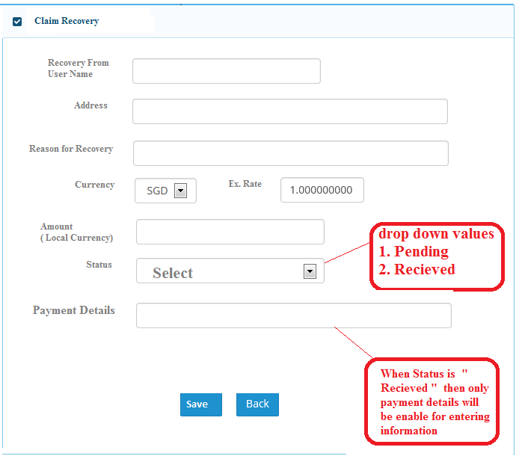

Consistent fonts and size please

Pending, Received and Discontinue statuses. Discontinue status is to take care of circumstances where recovery is not pursued anymore.

Please have consistent font. By default is “Pending”

Provide for 500 chars

Amend to – Recovery From